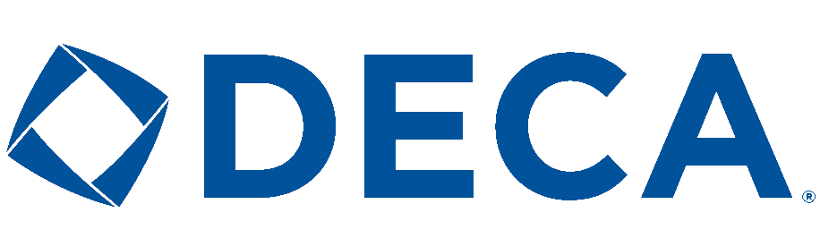
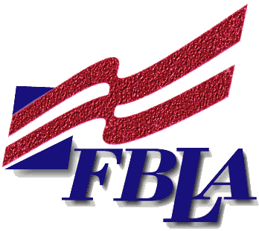
FBLA/DECA
Membership Form

Future Business Leaders of America (FBLA) and DECA are some of the oldest and largest national organizations for students preparing for careers in business. FBLA/DECA, associations of business and marketing students, are student organizations with over 400,000 members worldwide. The purpose of FBLA/DECA is to provide learning opportunities for business and marketing students through chapter activities and to prepare students for careers in business and business-related fields.

The mission of FBLA is to bring business and education together in a positive working relationship through innovative leadership and career development programs; the mission of DECA is to enhance the co-curricular education of students with the interests in marketing, management and entrepreneurship. Together they help students develop skills and competence for business and marketing careers, build confidence, experience leadership and practice community involvement.

FBLA/DECA will provide you with:
- Travel opportunities
- Challenging competitions
- Scholarships and awards
- Leadership development
- Community service experience
- Friendship and FUN!!!

Members have the opportunity to compete for awards and recognition on the local, state, and national levels in more than 50 different event categories including Website development, marketing, business plan, public speaking, sports marketing, travel & tourism, job interview, network design, and many more! Become a leader in your school, state, or country when you become an officer. Win money! Travel! Learn to lead! Develop friendships! Earn recognition! All of these adventures and more await you when you become a member of FBLA/DECA!

Important Dates to Remember!!!
- First Meeting- September 7TH
- Fees Due- October 3rd
- Deadline for choosing events- November 16th
- DECA District Competition - January 6th (WI Rapids)
- FBLA Regional Competition – February 4th (Nekoosa)
- DECA State Competition - March 6-9 (Lake Geneva)
- FBLA State Competition – April 2-4 (Appleton)
- DECA International Competition - April 25-20 (Anaheim, CA)
- FBLA National Competition – June 28-July 3rd (Anaheim, CA)

FBLA/DECA Member Sign Up Form

Name: ____________________________________

Grade: ____________ Phone Number (Cell or Home): ________________
E-mail address: ___________________________________________________
I have enclosed $35.00 for local, state, and national (FBLA and DECA) dues or I have enclosed $25.00 (no shirt). (circle one)
T-shirt size: _________
Please check all that apply:
___________ I am interested in trying FBLA competition.
___________ I am interested in trying DECA competition.
___________ I am not interested in competition
**see www.fbla-pbl.org & www.deca.org for competitive events**
(There will be meetings with more information on the competitive events)
What business classes have you taken or are currently enrolled in? (circle all that apply)
- Accounting I h) Accounting 2, 3, or 4
- Marketing i) Employabilty Skills
- Webpage Development j) Personal Money Management
- Intro to Programming k) Intro to Digital Media
- Yearbook l) Business Law
- Computer Apps m)Independent Study

Returning Members - events from FBLA/DECA you participated in:
- ____________________________ years ___________ awards___________
- ____________________________ years ___________ awards___________
- ____________________________ years ___________ awards___________

Please return (form & money) to Ms. Fryar (DMC)

